Songs and Humour of Sea and Shore

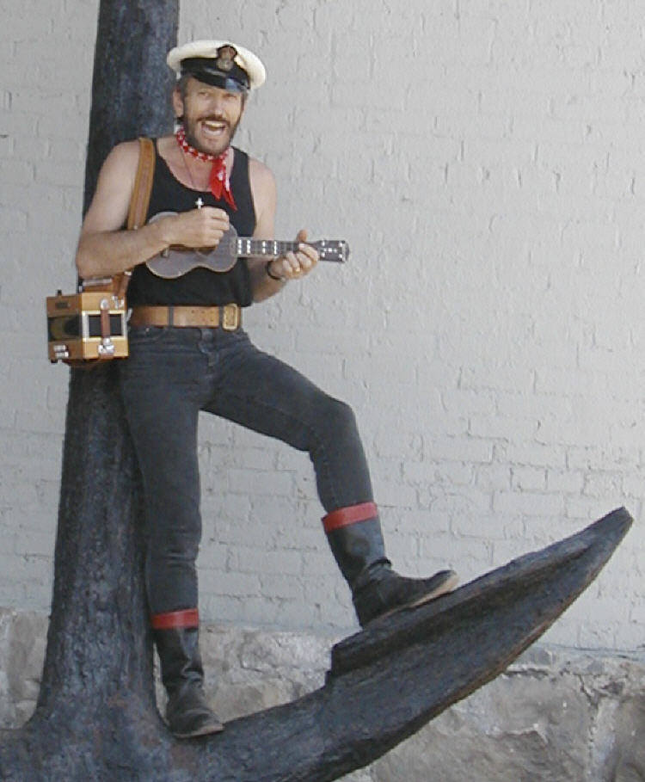

“ … the hit of the festival, he brought the house down.”

“It’s impossible not to sing along!”
(Photograph courtesy of the Foss Waterway Seaport, Tacoma, WA.)
Lewis
Tom
“In Concert” at :-

